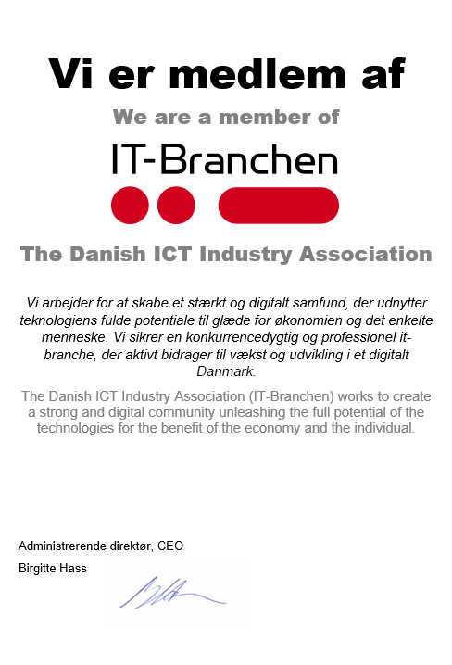

INDTAST NAVN har været medlem af IT-Branchen siden INDTAST ÅR
INSERT NAME has been a member of The Danish ICT Industry Association since INSERT YEAR

